**Math 155, *Lecture Notes- Bonds* Name____________**

***Section 9.8*** *Power Series*

In this section, we will learn that several types of important functions can be represented *exactly* by infinite series called **power series**.

For example,



Eventually, we will see that for each real number *x*, the infinite series on the right side will converge to the number .

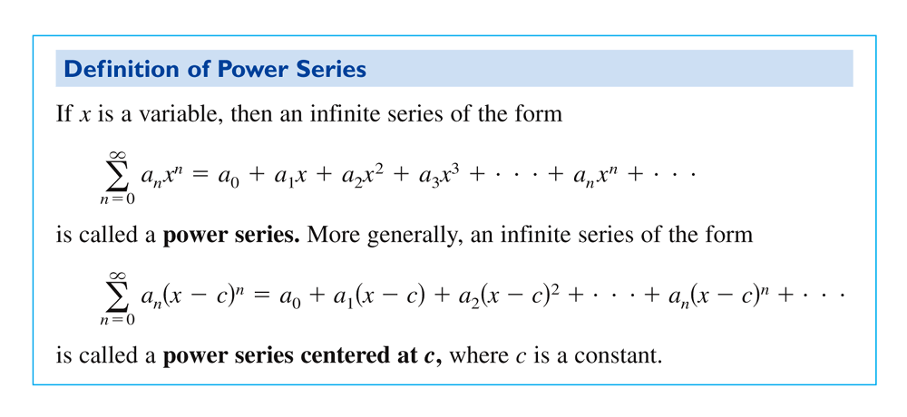

**Ex. 1: (a)**  =



**(b)**  =

We can view as a function of *x* where the domain of  is the set of all *x* for which the power series converges. Therefore, we will need to know the values of *x* that allow the series to converge, and determination of this domain will be the main focus of this section.



First, every power series converges at its center *c*:

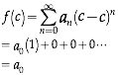 , where we are agreeing that , even if .

The domain of a power series has only three basic forms: a single point, an interval centered at *c*, or the entire real line.

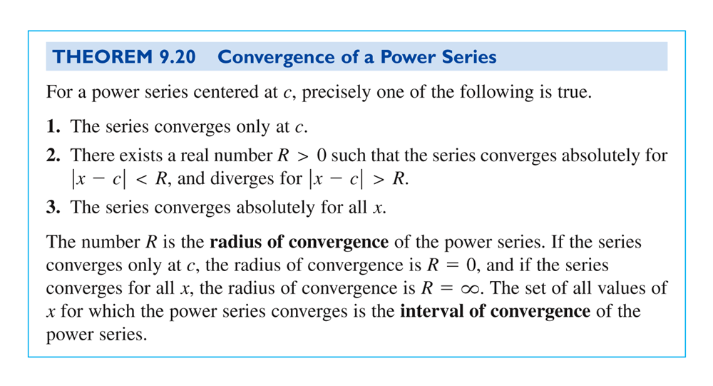

**Ex. 2:** Determine the interval of convergence of the series: 

Note that for a power series with a radius of convergence that is a finite number *R*, Theorem 9.20 says nothing about the convergence at the *endpoints* of the interval of convergence. In fact, each endpoint must be tested separately for convergence or divergence.

**Ex. 3:** Determine the interval of convergence of the series: 

More Ex. 3:

Still More Ex. 3:

**Ex. 4:** Determine the interval of convergence of the series: 

More Ex. 4:

Still More Ex. 4:

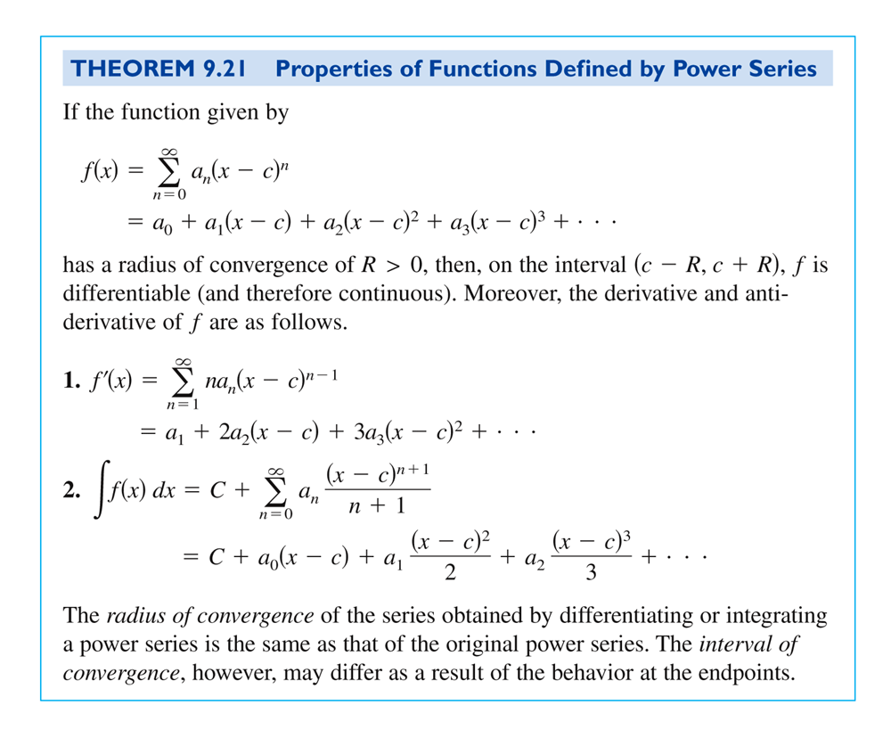

**Ex. 5:** Determine the interval of convergence for **(a)** , **(b)** , **(c)** , and **(d)** , given that .

More Ex. 5:

Still More Ex. 5:

**Ex. 6:** Given .

(a) Find the interval of convergence.

(b) Show that .

(c) Show that .

(d) Identify the function.

More Ex. 6:

More Ex. 6: